MEGHNAD SAHA INSTITUTE OF TECHNOLOGY

*Techno Complex, Madurdaha,Beside NRI Complex, Post-Uchhepota, Kolkata 700 150*

LABORATORY NOTE BOOK

MAKAUT EVEN SEMESTER 2025



[MASTERS OF COMPUTER APPLICATION]

[OBJECT ORIENTED PROGRAMMING LAB USING JAVA (MCAN-293)]

[RUPAK SARKAR]

ROLL NO: 14271024036 REGN. NO.: 241420510045

STREAM: MCA SEMESTER: II (2ND)

YEAR: 1ST YearSESSION: 2024-2026



MAULANA ABUL KALAM AZAD UNIVERSITY OF TECHNOLOGY



MEGHNAD SAHA INSTITUTE OF TECHNOLOGY

*Techno Complex,. Madurdaha,Beside NRI Complex, Post-Uchhepota, Kolkata 700 150*

“LIST OF ASSIGNMENT/EXPERIMENT SUBMISSION DETAILS”

|  |  |  |  |  |  |
| --- | --- | --- | --- | --- | --- |
| **SL.**  **NO.** | **ASSIGNMENT / EXPERIMENT NAME** | **DATE OF EXPERIMENT** | **DATE OF SUBMISION** | **CHECKED BY** | **REMARKS (ANY DEVIATION REGARDING SUBMISSION DATES, CONTENT, FORMAT, ETC)** |
| 1. | WAP to change from Fahrenheit to Celsius. | 10/02/2025 | 17/02/2025 |  |  |
| 2. | WAP to check number is Even or Odd. | 10/02/2025 | 17/02/2025 |  |  |
| 3. | WAP to swap numbers with & without using third variable. | 10/02/2025 | 17/02/2025 |  |  |
| 4. | WAP to find greatest of three numbers. | 10/02/2025 | 17/02/2025 |  |  |
| 5. | WAP to find Leap Year. | 10/02/2025 | 17/02/2025 |  |  |
| 6. | WAP to find all numbers divisible by 7 from numbers 1-100. | 10/02/2025 | 17/02/2025 |  |  |
| 7. | WAP to find area and circumference of a circle. | 10/02/2025 | 17/02/2025 |  |  |
| 8. | WAP to find roots of quadratic equation. | 10/02/2025 | 17/02/2025 |  |  |
|  |  |  |  |  |  |
|  |  |  |  |  |  |

|  |
| --- |
| OBSERVATIONS / COMMENTS ON THE OVERALL PERFORMANCE: |

Signature in full with date Signature in full with date

**Faculty / Technical Assistant Lab Examiner**

**Q.1. Write a program to change from Fahrenheit to Celsius.**

Ans:

class temp{

public static void main(String args[])

{

int c=25,f;

f = ((c*9)/5)+32;

System.out.println("The converted Fahrenheit is: " +f);

}

}

Output:

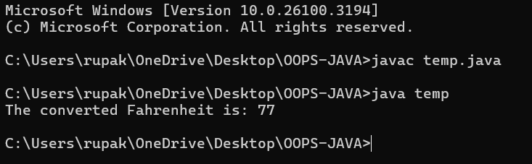

**Q.2. Write a program to check whether a number is Even or Odd.**

Ans:

class evenodd{

public static void main(String args[])

{

int a=10;

if(a%2==0)

{

System.out.println(a+ " is Even Number.");

}

else

{

System.out.println(a+ " is Odd Number.");

}

}

}

Output:

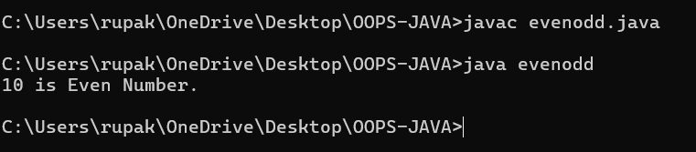

**Q.3. Write a program to swap three numbers using with and without using three numbers.**

Ans:

**Using Three Variables:**

class swap{

public static void main(String args[])

{

int a=10,b=20,c=0;

System.out.println("Before Swap: a: "+a+ " b: "+b);

c=a;

a=b;

b=c;

System.out.println("After Swap: a: "+a+ " b: "+b);

}

}

Output:

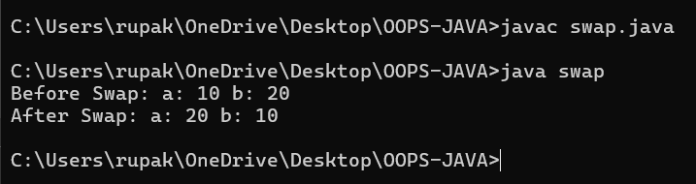

**Without Using Three Variables:**

class swap2{

public static void main(String args[])

{

int a=11,b=21;

System.out.println("Before Swap: a: "+a+ " b: "+b);

a=a+b;

b=a-b;

a=a-b;

System.out.println("After Swap: a: "+a+ " b: "+b);

}

}

Output:

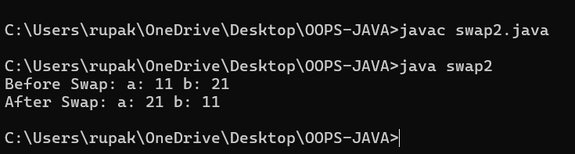

**Q.4. Write a program to find greatest of three numbers.**

Ans:

class greatest{

public static void main(String args[])

{

int a=10,b=20,c=30;

if(a>b && a>c)

{

System.out.println("A is greatest.");

}

else if(b>c && b>c)

{

System.out.println("B is greatest.");

}

else

{

System.out.println("C is greatest");

}

}

}

Output:

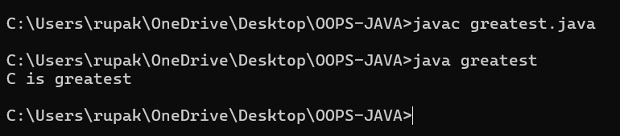

**Q.5. Write a program to find whether a year is Leap Year or Not.**

Ans:

class leap

{

public static void main(String args[])

{

int leap=2024;

if(leap%4==0 && leap%100!=0)

{

System.out.println(leap+ " is Leap Year.");

}

else if(leap%400==0 && leap%100==0)

{

System.out.println(leap+ " is a Leap Year.");

}

else

{

System.out.println(leap+ " is not Leap Year.");

}

}

}

Output:

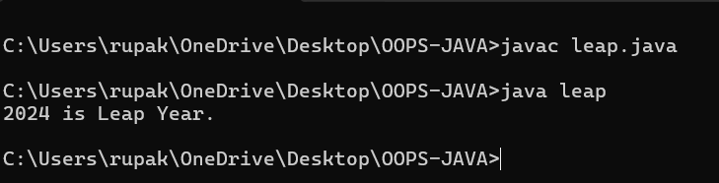

**Q.6. Write a program to find all the numbers divisible by 7 from range 1-100.**

Ans:

class divisor{

public static void main(String args[])

{

int a;

for(a=0;a<=100;a++)

{

if(a%7==0)

{

System.out.println(a);

}

}

}

}

Output:

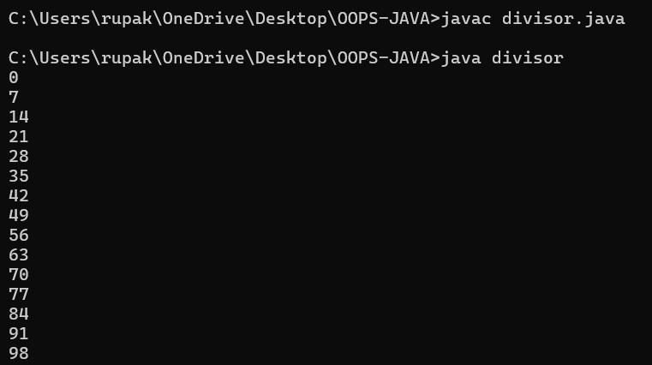

**Q.7. Write a program to find Area and Circumference of a circle.**

Ans:

class arcirc{

public static void main(String args[])

{

int r=10;

double pi=3.14;

double area = pi*r*r;

double circum = 2*pi*r;

System.out.println("Area of Circle is: "+area);

System.out.println("Circumference of is: "+circum);

}

}Output:

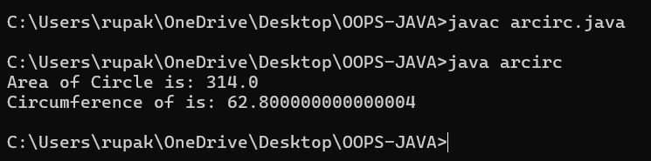

**Q.8. Write a program to find roots of a Quadratic Equation.**

Ans:

class quadratic {

public static void main(String args[])

{

double a = 10, b = 8, c = 6;

double firstroot, secondroot;

double det = b * b - 4 * a * c;

if (det > 0)

{

firstroot = (-b + Math.sqrt(det)) / (2 * a);

secondroot = (-b - Math.sqrt(det)) / (2 * a);

System.out.format("First Root = %.2f and Second Root = %.2f",firstroot, secondroot);

}

else if (det == 0)

{

firstroot = secondroot = -b / (2 * a);

System.out.format("First Root = Second Root = %.2f;", firstroot);

}

else

{

double real = -b / (2 * a);

double imaginary = Math.sqrt(-det) / (2 * a);

System.out.printf("First Root = %.2f+%.2fi", real, imaginary);

System.out.printf("\nSecond Root = %.2f-%.2fi", real, imaginary);

}

}

}

Output:

